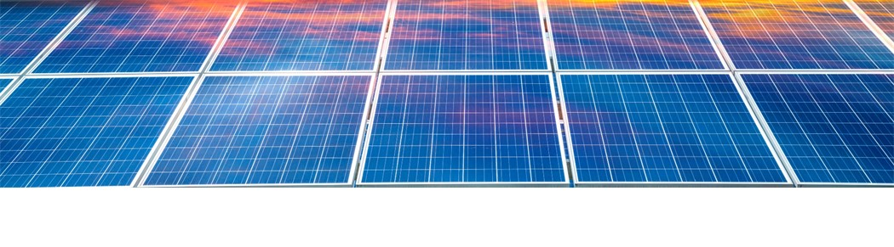
Solar power plant final project update requirements form

Date: Applicant’s company name:
Type, number and physical dimensions of solar modules, including solar tracking system

(Note: the type, number and physical dimensions of solar modules, including solar tracking system can change).
Confirm the final type and number of solar modules, the physical dimensions of the solar array, and the type of solar tracking system, if applicable:

Provide confirmation that the changes do not cause new solar glare to occur at critical points along highways, major roadways and railways and any registered and known unregistered aerodromes:

Total capability of power plant in MW

(Note: the total capability cannot increase or decrease by more than +/- 10 per cent or +/- 10 MW, whichever is less).
Confirm total capability of power plant in MW:

Extent of land use disturbance located within the approved project boundary
(Note: extent of land use disturbance may increase or decrease.)
Confirm extent of land use disturbance (in hectares) located within the approved project boundary:

Total disturbance to native grassland or other types of wildlife habitat, encroachment into Alberta Environment and Protected Areas (AEPA) minimum setbacks for wildlife habitat features; or, any encroachments into AEPA’s minimum setbacks for permanent wetlands.
(Note: the total disturbance or encroachment cannot increase).
Confirm total disturbance (in hectares) to native grassland or other types of wildlife habitat have not increased over what has been approved:

Confirm encroachment into AEPA’s minimum setbacks for wildlife habitat features has not increased over what has been approved:

Confirm any encroachments into AEPA’s minimum setbacks for permanent wetlands have not increased over what has been approved:

Noise environment
(Note: the noise environment must continue to meet permissible sound levels at the most affected receptors (as determined under Rule 012).
Provide sound output of noise generating equipment:

Provide table of predicted noise levels (to one decimal point) from finalized project receptors.
[Please submit along with your form].

Confirm that the project continues to meet permissible sound levels at the most affected receptors (as determined under Rule 012):

Provide any new or additional noise mitigation measures implemented to ensure that permissible sound levels will be met:

Participant involvement program
(Note: if new or additional notification or consultation is required, including any requirements under Rule 012, there cannot be any unresolved objections arising from the final project update.)
Confirm that new or additional notification or consultation either was not required or that it was undertaken. Provide a summary of any new or additional notification or consultation that was undertaken:

Confirm that there are no unresolved objections to the project arising from the final project update:

Final plant site layout
(Note: the solar array and collector substation cannot be relocated more than 100 metres from the approved location).

Provide a final plant site drawing and map showing the location of the project’s solar array, collector substation(s), roads, collector lines and the site boundary and provide a .kml/.kmz file. [Please submit along with your form].

Confirm that the location of the solar array and collector substation(s) has not been relocated more than 100 metres from the approved location:

If changes are made to the layout of access roads and collector lines, provide confirmation from an experienced wildlife biologist that the changes do not infringe on any wildlife habitat or any wildlife features, or alter any mitigation commitments. Confirm that the changes all occur within the approved project boundary:
Project boundary
(Note: approved project boundary cannot increase.)
Confirm that the approved project boundary has not increased:

When complete, save a copy of this form as a PDF file and submit the file to the AUC through the eFiling System.

