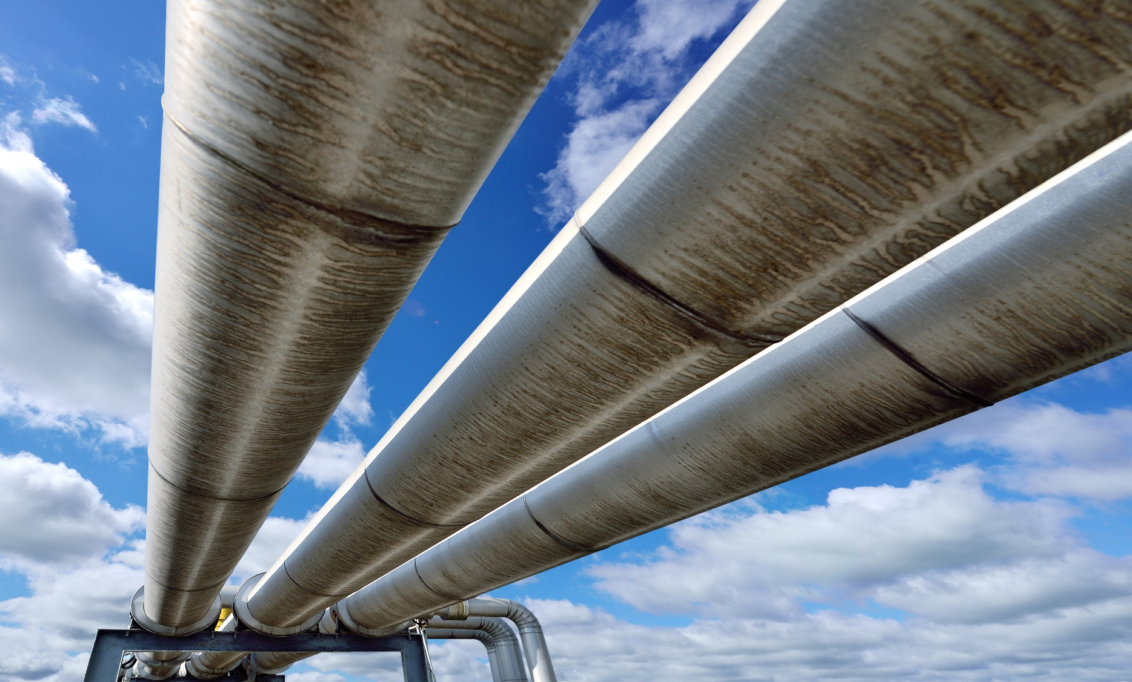

**Gas utility pipeline   
checklist amendment application**

**Date**:

|  |
| --- |
| **Identification** |
| **Company name**:  **Name, position and contact information of applicant contact**: |
| **Project details** |
| **Provide a list of the existing licences or approvals for facilities affected by the amendment**: |
| **Identify the type of licence amendment being applied for**:  **Pipeline discontinuation**  **Pipeline abandonment**  **Low pressure conversion**  **Maximum operating pressure decrease**  **Pipeline split**  **Administrative or record keeping updates** |
| **Brief description of the amendment**: |
| **Is the amendment related to another existing proceeding or project?**  **Yes**  **No**  **If yes, please provide the related proceeding number**: |
| **For pipeline discontinuation amendments** |
| **Confirm that proper discontinuation procedures are in place, cathodic protection is maintained, and setback distances are retained (right-of-way boundaries)**:    **Yes**  **No** |
| **For pipeline abandonment amendments** |
| **Confirm that this form is being submitted within 90 days of the completion of the abandonment**:  **Yes**  **No**  **Please provide the abandonment date:** |
| **Confirm that proper abandonment procedures are in place, and that all required measures have been taken to ensure that the pipeline is left in a permanently safe and secure condition**:  **Yes**  **No** |
| **For maximum operating pressure decrease amendments** |
| **Confirm that all necessary mitigation measures have been taken to ensure continued pipeline integrity under the new maximum operating pressure**:  **Yes**  **No** |
| **Confirm that all necessary mitigation measures have been taken to ensure pressure compatibility with upstream and downstream pipelines (i.e., any necessary adjustments in overpressure protection)**:  **Yes**  **No** |
| **For all types of amendments** |
| **Confirm that the participant involvement program meets the requirements contained in Appendix A1 – Participant involvement program guidelines of Rule 007**:  **Yes**  **No**  **Confirm that there are no outstanding concerns raised by directly and adversely affected persons**:  **Yes**  **No** |
| **Confirm that the applicant considers the proposed amendment to be low risk activities**:  **Yes**  **No** |
| **Confirm that there will be no adverse environmental effects resulting from the proposed amendment**:  **Yes**  **No** |
| **If “No” was selected for any of the prior questions, please provide further explanation**: |
| **The project raises issues not addressed by the preceding questions:**  **Yes**  **No**  **If Yes, please explain**: |

**Pipeline Segment/Pipeline Installation Identification**

|  |
| --- |
| **APPLICANT’S REFERENCE** |
|  |

|  |  |  |  |  |  |  |  |  |
| --- | --- | --- | --- | --- | --- | --- | --- | --- |
| **DAY** | | **MONTH** | | | **YEAR** | | | |
|  |  |  |  |  |  |  |  |  |

**1. PIPE SPECIFICATION/SUBSTANCE**

**Substance Code H2S (mol/kmol) Licence Number**

|  |  |  |  |  |  |  |  |  |  |
| --- | --- | --- | --- | --- | --- | --- | --- | --- | --- |
| **ID No.** | **Outside Diameter (mm)** | **Wall Thickness (mm)** | **Material** | **Type** | **Grade** | **MOP (kPa)** | **Stress Level** | **Joints** | **IP** |
| **01** |  |  |  |  |  |  |  |  |  |
| **02** |  |  |  |  |  |  |  |  |  |
| **03** |  |  |  |  |  |  |  |  |  |
| **04** |  |  |  |  |  |  |  |  |  |
| **05** |  |  |  |  |  |  |  |  |  |

**2. PIPE LOCATION AND STATUS**

|  |  |  |  |  |  |  |  |  |  |  |  |  |  |  |  |  |  |
| --- | --- | --- | --- | --- | --- | --- | --- | --- | --- | --- | --- | --- | --- | --- | --- | --- | --- |
| **ACD** | **Line No.** | **From Location** | | | | | **FC** | **To Location** | | | | | **FC** | **Length   (km)** | **Status** | **Environment** | **ID  No.** |
| **LSD** | **SEC** | **TWP** | **RGE** | **M** | **LSD** | **SEC** | **TWP** | **RGE** | **M** |
|  |  |  |  |  |  |  |  |  |  |  |  |  |  |  |  |  |  |
|  |  |  |  |  |  |  |  |  |  |  |  |  |  |  |  |  |  |
|  |  |  |  |  |  |  |  |  |  |  |  |  |  |  |  |  |  |
|  |  |  |  |  |  |  |  |  |  |  |  |  |  |  |  |  |  |
|  |  |  |  |  |  |  |  |  |  |  |  |  |  |  |  |  |  |
|  |  |  |  |  |  |  |  |  |  |  |  |  |  |  |  |  |  |
|  |  |  |  |  |  |  |  |  |  |  |  |  |  |  |  |  |  |

**3. INSTALLATION SPECIFICATION**

|  |  |  |  |  |  |  |  |  |  |  |
| --- | --- | --- | --- | --- | --- | --- | --- | --- | --- | --- |
| **ACD** | **Installation**  **No.** | **Location** | | | | | **Installation Type** | **Compressor Rating (kW)** | **Driver Power Source** | **Status** |
| **LSD** | **SEC** | **TWP** | **RGE** | **M** |
|  |  |  |  |  |  |  |  |  |  |  |
|  |  |  |  |  |  |  |  |  |  |  |
|  |  |  |  |  |  |  |  |  |  |  |

**Table 1        Substance categories**

|  |  |  |  |
| --- | --- | --- | --- |
| **Substance** | **Substance category** | **Code** | **Priority code** |
| Methane, natural gas with H2S partial pressure < 0.30 kPa. | Natural gas | NG | 6 |

**Table 2        Pipe material codes**

|  |  |
| --- | --- |
| **Pipe material** | **Code** |
| Aluminum | A |
| Composite | G |
| Fibreglass | F |
| Polyethylene | P |
| Polyvinyl chloride | V |
| Steel | S |

**Table 3        Steel pipe codes (examples only)**

|  |  |  |
| --- | --- | --- |
| **Pipe specification** | **Code** | |
| **Type** | **Grade** |
| API 5L Grade A | 5L | A |
| API 5L Grade B | 5L | B |
| API 5L Grade X42 | 5L | X42 |
| API 5L Grade X60 | 5L | X60 |
| ASTM A53 Grade B | A53 | B |
| ASTM A106 Grade B | A106 | B |
| ASTM A333 Grade 6 | A333 | 6 |
| CSA Z245.1 Grade 241 Category I | Z245.1 | 241 1 |
| CSA Z245.1 Grade 290 Category II | Z245.1 | 290 2 |
| CSA Z245.1 Grade 359 Category III | Z245.1 | 359 3 |
| ASTM A539 | A539 | N/A * |

*Not applicable for ASTM A539.

**Table 4        Aluminum pipe codes (examples only)**

|  |  |  |
| --- | --- | --- |
| **Pipe specification** | **Code** | |
| **Aluminum Association Alloy No.** | **Type** | **Grade\*** |
| 6063 T1A | 6063 | T1A |
| 6063 T1B | 6063 | T1B |

If cladded aluminum, add C at the end of Grad Code (e.g.) T1AC).

**Table 5        Fibreglass and fibre-reinforced composite pipe codes (examples only)**

|  |  |  |
| --- | --- | --- |
| **Pipe specification** | **Code** | |
| **Type** | **Grade\*** |
| Ameron Bondstrand 3000 | AMERON | 3000 |
| Star Fibreglass 500 | STAR | 500 |
| Centron 800 | CEN | 800 |
| Fibrespar 1500 E | FSLP | 1500 |
| Hydril ANSI 300 | HDLP | 300 |
| Flexpipe (ANSI 300) | FPLP | 750 |
|  |  |  |

**Table 6        Polyethylene pipe codes (examples only)**

|  |  |  |
| --- | --- | --- |
| **Pipe specification** | **Code** | |
| **Aluminum Association Alloy No.** | **Type** | **Grade\*** |
| PE 2406 SDR 11 | 2406 | 11 |
| PE 3408 SDR 9 | 3408 | 9 |

**Table 7        Joint codes**

|  |  |
| --- | --- |
| **Joint** | **Code** |
| Thru-Kote Welded | A |
| Butt Fusion | B |
| Bonded | C |
| Flanged | F |
| Solvent Welded | G |
| High Energy Welded | H |
| Crimp Kote | K |
| Sure Lok | L |
| Mechanical Coupling | M |
| Pronto Lock | P |
| Socket Fusion | S |
| Threaded | T |
| Welded | W |
| Zap-Lok | Z |
| Twin Lock | E |
| Triple Seal | R |



**Table 8        Internal protection codes**

|  |  |
| --- | --- |
| **Protection type** | **Code** |
| Uncoated | U |
| Thin Film | T |
| Cement | C |
| Expanded Polyethylene | E |
| Grouted | G |
| Free Standing | L |

**Table 9        Facility codes\***

|  |  |
| --- | --- |
| **Facility** | **Code** |
| Compressor Station | CS |
| Meter/Regulation Station | MR |
| Meter Station | MS |
| Pipeline | PL |
| Regulator Station | RS |
| Line Heater | LH |
| Gas Processing Plant | GP |
| Blind End | BE |
| Petrochemical Plant | PP |
| Refinery | RF |
| Storage Cavern | SC |
| * If facility code is not set out above, use AER facility code. |  |

**Table 10  Status codes**

|  |  |
| --- | --- |
| **Status** | **Code** |
| Abandoned | A |
| Discontinued | D |
| Operating | O |
| Removed | R |
| To Be Constructed | P |
| Delete from Licence | X |
| Not Constructed | N |

**Table 11  Environment codes**

|  |  |
| --- | --- |
| **Crossing** | **Code** |
| Creek | CC |
| Lake | LC |
| Overhead | OC |
| River | RC |
| Surface (surface line) | SC |

**Table 12  Pipeline installation codes**

|  |  |
| --- | --- |
| **Facility** | **Code** |
| Compressor Station | CS |

 **Table 13  Driver power source codes**

|  |  |
| --- | --- |
| **Facility** | **Code** |
| Natural Gas | N |
| Electric | E |

**Table 14        Status codes for pipeline installations**

|  |  |
| --- | --- |
| **Status** | **Code** |
| Operating | O |
| Removed | R |
| To Be Constructed | P |
| Delete from Licence | X |
| Not Constructed | N |

**When complete, save a copy of this form as a PDF file and submit the file to the AUC through the eFiling System.**