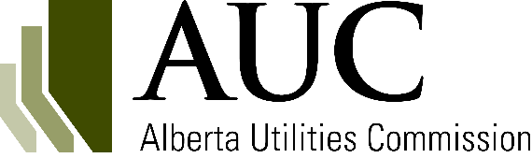
Energy storage facility decommission and salvage application

Date: Applicant’s company name:
Information requirements

Decommission and salvage application requirement (DSES1)
Provide the approval of the facility to be decommissioned or salvaged.
[Please submit along with your application form].
Decommission and salvage application requirement (DSES2)
Provide a letter from the independent system operator (ISO) or distribution facility owner endorsing the project.

[Please submit along with your application form].
Decommission and salvage application requirement (DSES3)
Provide information on the salvage, remediation and reclamation work to be performed; assessment of contamination; and legislative requirements or other published guidelines that will be adhered to or considered.
Decommission and salvage application requirement (DSES4)
Confirm that decommissioning will take place in alignment with any cleanup and reclamation plan in place.
Decommission and salvage application requirement (DSES5)
Provide a cost estimate and the schedule for the salvage.
[Please submit along with your application form].

Decommission and salvage application requirement (DSES6)
Confirm that personal notification was provided to occupants, residents, landowners, Indigenous groups and other utilities directly adjacent to the project boundary.

Decommission and salvage application requirement (DSES7)
Identify all persons who expressed a concern(s) about the project. For each person, include the following information:
- The specifics of the concern(s).
- Steps taken to resolve the concern(s).
- Whether the concern(s) was resolved.

When complete, save a copy of this form as a PDF file and submit the file to the AUC through the eFiling System.

